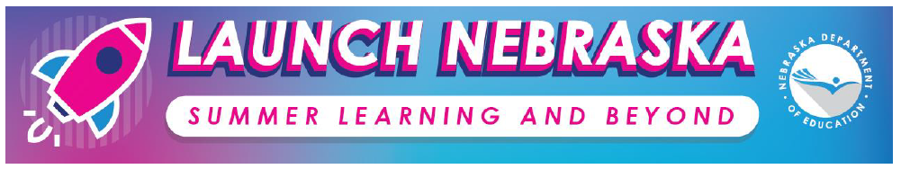
Summer Learning for Literacy
Freely Available Resources

Description: The purpose of this document is to provide a collection of resources to support summer learning for literacy through remote learning. Resources in this document are freely available and may be used in a variety of ways by a variety of stakeholders to support students’ literacy development. Resources are categorized as “enrichment resources” or “educational resources” to support you in thinking through how you may use these; however, we encourage you to be creative and implement these as best works for your school and community.

“Enrichment Opportunity” Resources

In an alternate learning environment, enrichment opportunities support the on-going development of particular knowledge and skills and the continuation of learning within a grade level. Enrichment opportunities can also help students build strong practices which are critical components of content area standards. These opportunities can be provided via multiple platforms and settings, may not require an instructor, and might be the same for all students. The opportunities can be provided by a parent, a caregiver, or through independent practice.

Resources for Text Access

Resource | Notes
Website: https://www.overdrive.com/
Purpose: This website provides text access to a range of e-books and audiobooks through the local public library and school.
Website: https://www.storylineonline.net/library/
Purpose: This website streams videos of celebrities and public figures reading aloud children’s books.
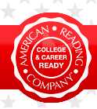 | Website: https://www.americanreading.com/  Purpose: American Reading Company is offering free access to some books for students and families.
Resources for Supporting Reading in the Home
Resource | Notes
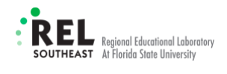 | Website: https://tinyurl.com/RELResource  Purpose: This resource (“Supporting Your Child’s Reading At Home” from REL is a collection of videos and activities that provide families with information about how to support children as they practice foundational reading skills at home.
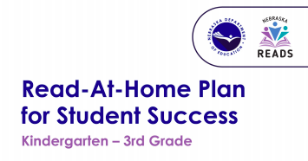 | Website: https://tinyurl.com/NEReadatHome  Purpose: This resource (available in English and Spanish) was created to assist parents and families in understanding how to support their child’s reading development and progress. It includes guidance on how to use materials found around the home to practice the skills necessary to help their child become a fluent reader.
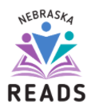 | Website: https://tinyurl.com/NESummerReadingOpps  Purpose: This website (part of Nebraska Reads) provides a compilation of recommended Summer Reading resources and opportunities.

“Educational Opportunity” Resources
Educational opportunities include standards-based instruction utilizing evidence-based teaching and learning practices. These opportunities are facilitated by an instructor in a synchronous, asynchronous, or blended learning environment. For example, an instructor might provide “live” or recorded instruction via a video conferencing platform that is aligned to their content area standards, has a method to collect student work, and provides feedback to students. As another example, a school might provide instructional packets to students with the expectation that teachers schedule small group weekly check-ins via telephone to provide feedback, answer questions, and engage in small group instruction (when possible).

Resource | Notes
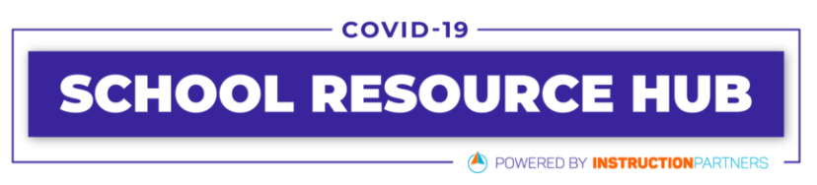 | Website:https://www.schoolresourcehub.org/grab- and-go  Purpose: Grab and Go Instructional Materials are readymade resources school leaders and teachers can use as a starting point or a model for their own materials. All resources can be used free of charge, and adaptations are allowed and encouraged.
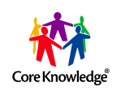 | Website: https://www.coreknowledge.org/blog/ free-online-core-knowledge-foundation-resources/  Purpose: This website includes links and descriptions of freely available resources from the high-quality and shifts-aligned curriculum, Core Knowledge. This includes curricular resources that were already available, and newly available resources they are creating in response to supporting educators in this current context.
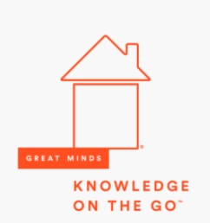 | Website: https://tinyurl.com/GreatMindsontheGo  Purpose: Great Minds has released over a thousand freely available video lessons and other supplemental resources for ELA, Math, and Science grounded in their high-quality curricula (ELA: Wit and Wisdom). This page links to various grade level and subject content.
Website: https://eleducation.org/what-we-offer/ coronavirus-resource-center
Purpose: This resource center provides and overview of the freely available resources created by EL Education and released to support educators during Coronavirus.

Additional “Launch Nebraska” Resources:

Resource | Notes
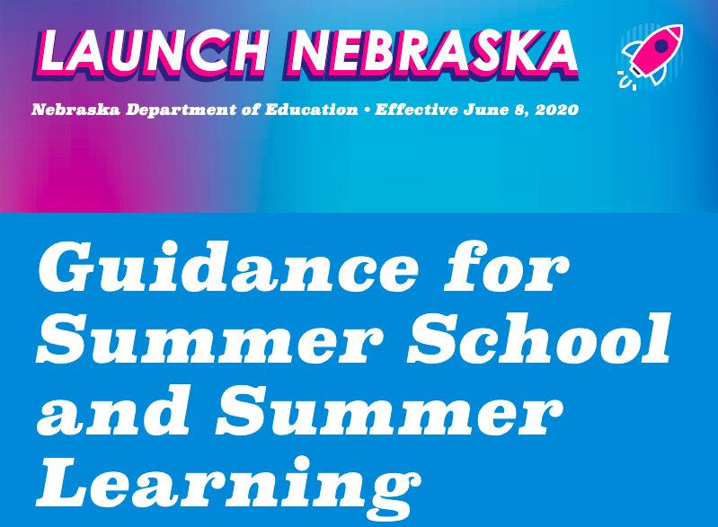 | Website: https://www.launchne.com/wp-content/ uploads/2020/05/AcademicGuidanceFinal2020.pdf  Purpose: This document provides guidance that can be used to plan summer learning opportunities and offers resources and considerations based on the shift to remote learning and research behind summer learning.
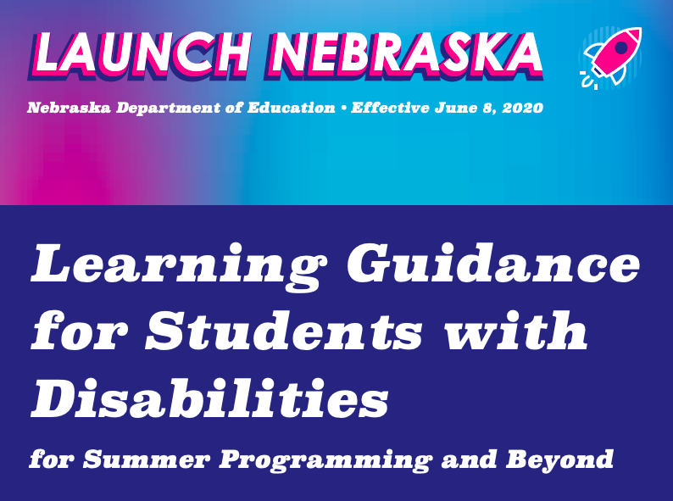 | Website: https://www.launchne.com/wp-content/ uploads/2020/05/SPEDGuidanceFinal2020.pdf  Purpose: This document provides guidance related to unfinished learning, extended school year, and compensatory education/services for students with disabilities.

